무대기술자료

TECHNICAL RIDER 2016.07ver

INTERPARK THEATER COMPANY. LTD. ALL RIGHT RESERVED. www.fan-square.com｜Venue Networks Team｜
INDEX

- 주요 시설 현황 ----------------------------------------------------- 3

- 무대 장비 현황 ----------------------------------------------------- 4

- 조명 인프라 현황 ----------------------------------------------------- 5

- 조명 장비 현황 ----------------------------------------------------- 6

- 음향 인프라 및 장비 현황 ----------------------------------------------------- 7

- 라이브홀 도면 ----------------------------------------------------- 9

1. 주요 시설 현황

▣ 객석 수 : Standing : 929석 / Seating : 424석
▷ 1층 : Standing : 800석 / Seating : 295석 (휠체어석 5석 포함)
▷ 2층 : 129석(Fixed)

▣ 무대제원
▷ 프로시니움 사이즈 : 16M(W) ⅹ 5.5M(H)
▷ 이동식 덧마루 주무대 사이즈 : 14.6M(W) ⅹ 6.5M(D)
▷ 무대 깊이 : 6M
▷ 측무대 사이즈
① 하수 프로시니움에서 하수 벽면 : 8.1M
② 상수 프로시니움에서 상수 벽면 : 6.3M

▣ Batten 제원
▷ Apron Batten (S1, S2, S3)
① 길이 : 15M
② 수량 : 3EA(Apron)
③ 속도 : UP-DN 6m/min
④ LIVE ROAD : 300Kg
⑤ 이동거리 : 1.5M - 5.7M
⑥ Driving Type : Winch Type

▷ Set Batten (S4, S5, S6)
① 길이 : 18M
② 수량: 3EA(Stage)
③ 속도 : UP-DN 6m/min
④ LIVE ROAD : 500Kg
⑤ 이동거리 : 1.5M - 5.7M
⑥ Driving Type : Winch Type

▷ Grid Batten (S7, S8, S9)
① 길이 : 18M ⅹ 1.35M
② 수량 : 3EA(Stage : 3EA)
③ 속도 : UP-DN 6m/min
④ LIVE ROAD : 700Kg
⑤ 이동거리 : 1.5M - 5.7M
⑥ Driving Type : Winch Type

▣ Loading Dock
▷ 반입구 : 1750(W) x 2900(H)
▷ Dock : 6370(W) x 1230(D) x 1025(H)

2. 무대 장비 현황

▣ 무대막
▷ 메인막 : 22M ⅹ 5.7M(고정 레일 수동식) - 1SET
▷ 다리막 : 2.4M ⅹ 5.7M(탈부착식) - 6EA
▷ 머리막 : 22M ⅹ 1M(탈부착식) - 1EA
▷ 샤 막 : White 22M × 5.7M - 1EA
Black 22M × 5.7M - 1EA
White 9.5M × 5.7M 2EA(메인 드로우 용)

▣ 무대 작업용 고소 사다리
▷ 높 이 : MAX 7.5M (작업 가능 높이 9.1M)
▷ 수 량 : 1EA
▷ LIVE ROAD : 175Kg
▷ Driving Type : Chain Link Type

▣ 무대 덧마루 (H : 300)
▷ 1820 ⅹ 910 : 48장
▷ 1820 ⅹ 1030 : 8장
▷ 1430 ⅹ 910 : 6장
▷ 1430 ⅹ 1030 : 1장
▷ 1470 ⅹ 910 : 2장(Sliding)
▷ 1820 ⅹ 860 : 4장(Sliding)
▷ 1030 ⅹ 860 : 2장(Sliding)

→ 덧마루 사용에 대한 내용 추가

3. 조명 인프라 현황
▣ Electric Power
▷ Main power : 3 phase 4 wire system, 380V - 220V, 60Hz, MCCB 4P, 600AF/ 500AT
NO | ITEM | MODEL / TYPE | Q'TY | ORIGIN
1 | FLY DUCT | APRON TOP LIGHT FLY DUCT | 3 | Korea
2 | FLY DUCT | STAGE LIGHT FLY DUCT | 2 | Korea
3 | FLY DUCT | NO1 STAGE LIGHT FLY DUCT | 2 | Korea
4 | FLY DUCT | NO2 STAGE LIGHT FLY DUCT | 2 | Korea
5 | FLY DUCT | NO3 STAGE LIGHT FLY DUCT | 2 | Korea
6 | FLY DUCT | NO1 CEILING LIGHT FLY DUCT | 1 | Korea
7 | FLY DUCT | NO2 CEILING LIGHT FLY DUCT | 1 | Korea
8 | WALL POCKET | BALCONY WALL POCKET | 9 | Korea
9 | FLY DUCT | 객석 SIDE LIGHT FRAME(L, R) | 4 | Korea
10 | DIRECT PANEL | FOLLOW ROOM | 1 | Korea
11 | WALL POCKET | 12 OUTLET | 2 | Korea
12 | WALL POCKET | 4 OUTLET | 2 | Korea
13 | WALL POCKET | 8 OUTLET | 2 | Korea
14 | WALL POCKET | 5 OUTLET | 2 | Korea
15 | SPARE 분전반 | MCCB 4P 225AF/225AT | 2 | Korea
16 | MAIN & DIRECT PANEL | MAIN 4P 600AF/500AT | 1 | Korea
17 | 고조파필터 500A | 고조파필터 500A | 1 | Korea
18 | DIMMER UNIT PANEL | EURODIM | 3RACK | ADB(BEL)
19 | PATCH & NETWORK RACK | DMX SPLITTER 1IN 7OUTLET-6SET,NETWORKHUB | 1 | MA
20 | AUDITORIUM CONTROL CONSOLE | REMEMBRANCE 6CH | 1 | Leviton/USA
21 | CONNECTOR BOX | POWER & SIGNAL | 1 | Korea
22 | AUDITORIUM CONTROL BOARD | REMEMBRANCE 6CH | 1 | Leviton/USA
4. 조명 장비 현황
No | ITEM | MODEL / TYPE | Q’TY | ORIGIN
1 | Moving head | Robe color spot 575AT | 20 | ROBE
 |  | Robe color wash zoom 575AT | 8 | ROBE
 |  | LED Beam | 14 | LS MEDIA
2 | STROBE | Atomic 3000 | 4 | Martin
3 | STANDARD LIGHT | 4 Blinder | 8 | KUPO
 |  | PAR64 | 30 | KUPO
 |  | PAR46 | 16 | KUPO
 |  | SOURCE FOUR 19˚ | 10 | ETC
 |  | SOURCE FOUR 26˚ | 20 | ETC
 |  | SOURCE FOUR 36˚ | 18 | ETC
 |  | PROFILO 20`~50` | 20 | DTS
4 | IRIS | SOURCE FOUR 용 | 10 | ETC
5 | SPOT LIGHT | SCENA 1KW FRESNEL | 20 | DTS
6 | SPOT LIGHT | SCENA 1KW PC | 20 | DTS
7 | DMX SPLINTER | 1 IN / 6 OUT | 2 | DTS
8 | Fog Machine | Hazer-300 | 1 | Antari
9 | CABLE | c-type connector - 병렬 | 50 | 국내제작
 |  | c-type connector - 연결선(5m) | 20 | 국내제작
 |  | c-type connector - 연결선(10m) | 10 | 국내제작
 |  | 220 병렬선(1m) | 20 | 국내제작
 |  | 220 연결선(5m) | 30 | 국내제작
10 | FOLLOW SPOT LIGHT | X-ENON 1KW | 2 | USHIO
11 | LIGHT CONTROL CONSOLE | GRAND MA2 / 6 Port, 3072CH | 1 | MA
12 | BACK UP CONTROL CONSLE | NPU | 1 | MA

5. 음향 인프라 및 장비 현황

▣ Electric Power
▷ Main power : 3 phase 4 wire system, 380V - 220V, 60Hz

* POWER (TR3상4선식70KW)
ITEM | TYPE | Q'TY
무대 상수 분전반 | 3상 4선식 75A | 1
무대 하수 분전반 | 3상 4선식 75A | 1
F.O.H UPS | 6.8KW | 1

* MIXING CONSOLE
ITEM | ORIGIN | MODEL | TYPE | Q'TY
DIGITAL MIXING CONSOLE | MIDAS | PRO3 | IN-48CH, OUT-24CH PRO3 Control Centre,  DL251 Audio System I/O,  DL371 Audio System Engine,  DL444 8analogue mic in-  and 8analogue line out-module | 1set
DIGITAL MIXING SUB CONSOLE | YAMAHA | O1V96 |  | 1SET

* SPEAKER SYSTEM
ITEM | ORIGIN | MODEL | TYPE | Q'TY
MAIN L/R SPEAKER | MARTIN AUDIO | MLA COMPACT | POWERED | 24SET
SUB WOOFER | MARTIN AUDIO | MLA COMPACT | POWERED
CENTER SPEAKER | MARTIN AUDIO | MLA COMPACT | POWERED | 3
MONITOR SPEAKER | MARTIN AUDIO | LE2100S | 2 x12" 3-way Low Profile,  High Power Monitor 4 x NL4 | 4
 |  | LE1500S | 15" High Power Monitor 4 x NL4 | 6
 |  | LE1200S | 12" High Power Monitor 4 x NL4 | 2
MONITOR AMPLIFIER | MARTIN AUDIO | MA 5.2K | High Performance 1U Amplifier 2 x 2600W at 4ohms inc DSP | 2
MONITOR AMPLIFIER | MARTIN AUDIO | MA 2.8Q | Lightweight, 1U amplifIer 4 x 700W at 4ohms | 2
MONITOR CONTROLLER | MARTIN AUDIO | DX 2 | 4:8 Digital Loudspeaker Management System | 2

* PAGING SYSTEM
ITEM | ORIGIN | MODEL | TYPE | Q'TY
CEILING SPEAKER | MARTIN AUDIO | C4.8T | 2-Way 16 ohm - 70/100V 4" + 0.8" Ceiling Loudspeaker | 16
PAGING SPEAKER AMP | CROWN | CTS600 |  | 1
LOBBY SPEAKER | MARTIN AUDIO | AQ5 | 282(W)x172(H)x180(D) 3.5kg 2 x 5.25″ Ultra-compact 70/100V  2 x 5.25" ICT | 4
CONTROLLER | MARTIN AUDIO | AQX |  | 4
Compressor/Limiter | DBX | 160A |  | 1

* RIGGING SYSTEM
ITEM | ORIGIN | MODEL | TYPE | Q'TY
L/R SP. FLYING MOTOR | LK MOTOR | LK MOTOR | 1 TON | 4
CENTER SP. FLYING MOTOR | LK MOTOR | LK MOTOR | 0.5 TON | 2

*OUTBOARD & EFFECTER
ITEM | ORIGIN | MODEL | Q'TY
CD PLAYER | DENON | DN-D4500 | 1
VIDEO PLAYER | 360 SYSTEM | INSTANT REPLAY2 | 1
AUDIO INTERFACE | Sound Devices | 4Pre | 1
Finalizer | TC Electronic | Finalizer96k | 1
AUDIO DISTRIBUTOR | LA AUDIO | DA6 | 1

* MICROPHONE &STAND
ITEM | ORIGIN | MODEL | Q'TY
MICROPHONE | SHURE | BETA 52 | 1
MICROPHONE | SHURE | BETA 98 DS | 5
MICROPHONE | SHURE | BETA 91 | 1
MICROPHONE | SHURE | SM 57 | 10
MICROPHONE | SHURE | SM 58 | 8
MICROPHONE | SHURE | SM 81 | 4
WIRELESS MIC RECEIVER | SHURE | UR4D+ | 4
WIRELESS MIC BELTPACK | SHURE | UR1 | 2
WIRELESS MIC HANDMIC | SHURE | UR2+BETA87A | 6CH
MIC STAND | K&M | 21060-300-55 | 10
MIC STAND | K&M | 27195-300-55 | 8
MIC STAND | K&M | 25900-300-55 | 4
MIC STAND | K&M | 25950-300-55 | 2

* INTERCOM SYSTEM
ITEM | ORIGIN | MODEL | Q'TY
MAIN STATION | CLEARCOM | MS-702 | 1
INTERCOM STATION | CLEARCOM | KB-701 | 1
V-BOX | CLEARCOM | V-BOX | 1
BELTPACK | CLEARCOM | RS-601 | 10
HEADSET | STANTON | DJ PRO2 | 10
REMOTE STATION | CLEARCOM | RM-702 | 1
INTERCOM MIC | CLEARCOM | GM18 | 1

* VISUAL SYSTEM
ITEM | ORIGIN | MODEL | Q'TY
CCD CAMERA | SONY | BRC-300 | 1
CCD CAMERA CONTROLLER | SONY | RMBR-300 | 1
PTZ CAMERA | SAMSUNG | SCP-2370 | 1
PAN/TILT CONTROLLER | SAMSUNG | SPC-1010 | 1
IR DOME CAMERA | SAMSUNG | SCD-2081 | 4
VIDEO DISTRIBUTION AMPLIFIER | SAMSUNG | SVD-300 | 2
A/V SELECTOR | NES | NRS-808AV | 2
QUAD | NES | CMV-420Q | 2
DVR RECORDER/PLAYER | SAMSUNG | SRD-870DC | 1

6. 라이브홀 도면

▷ 1층 스탠딩공연 평면도

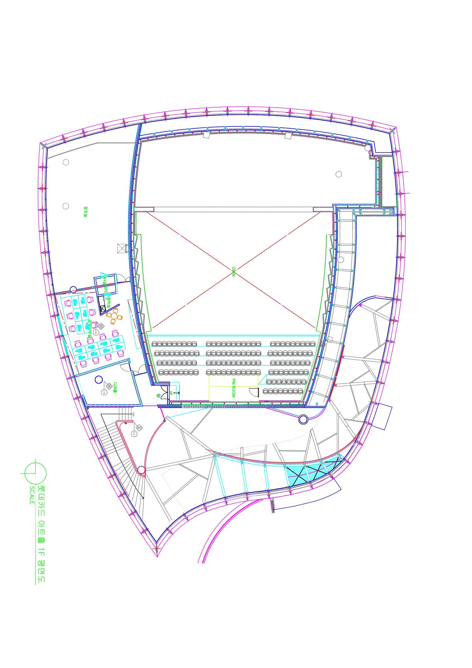

▷ 1층 객석공연 평면도

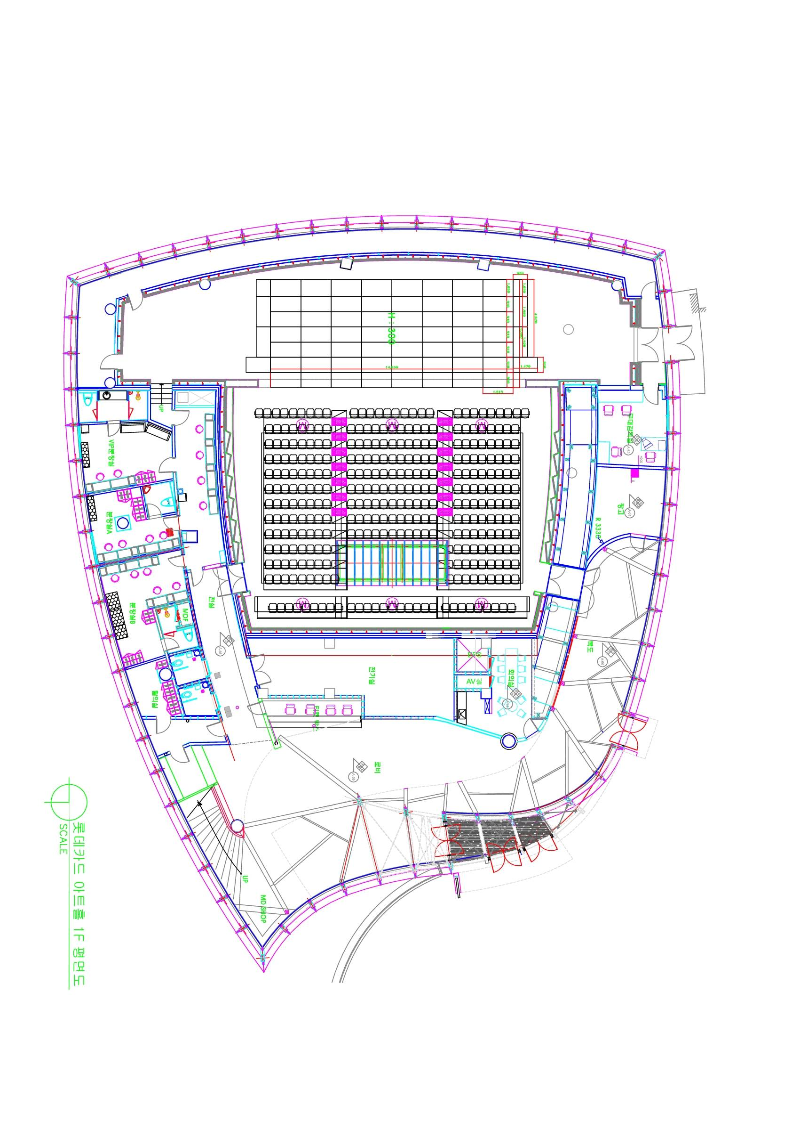

▷ 캣워크 평면도

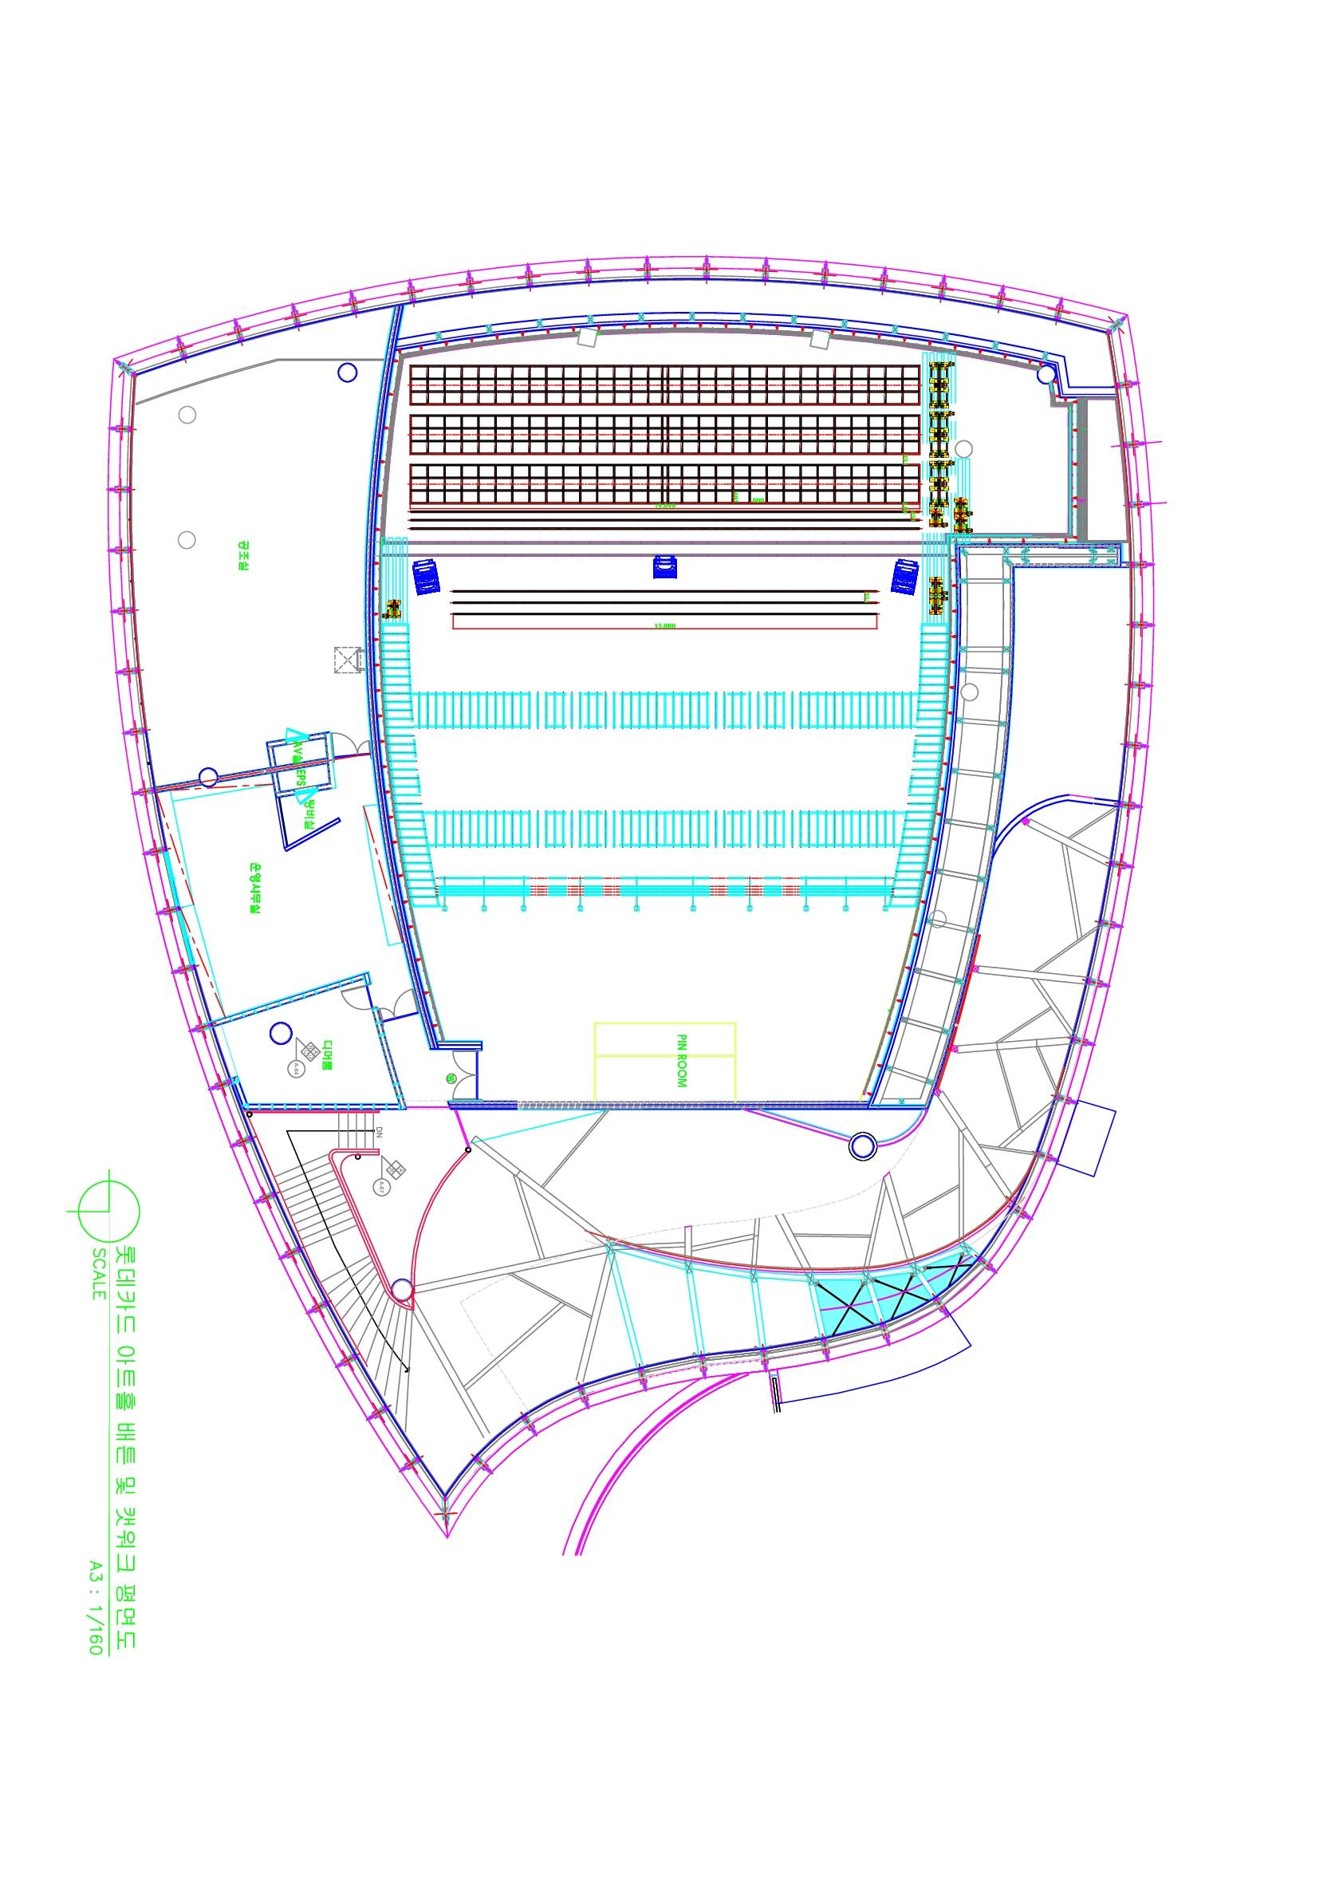

▷ 조명 회로 배치도

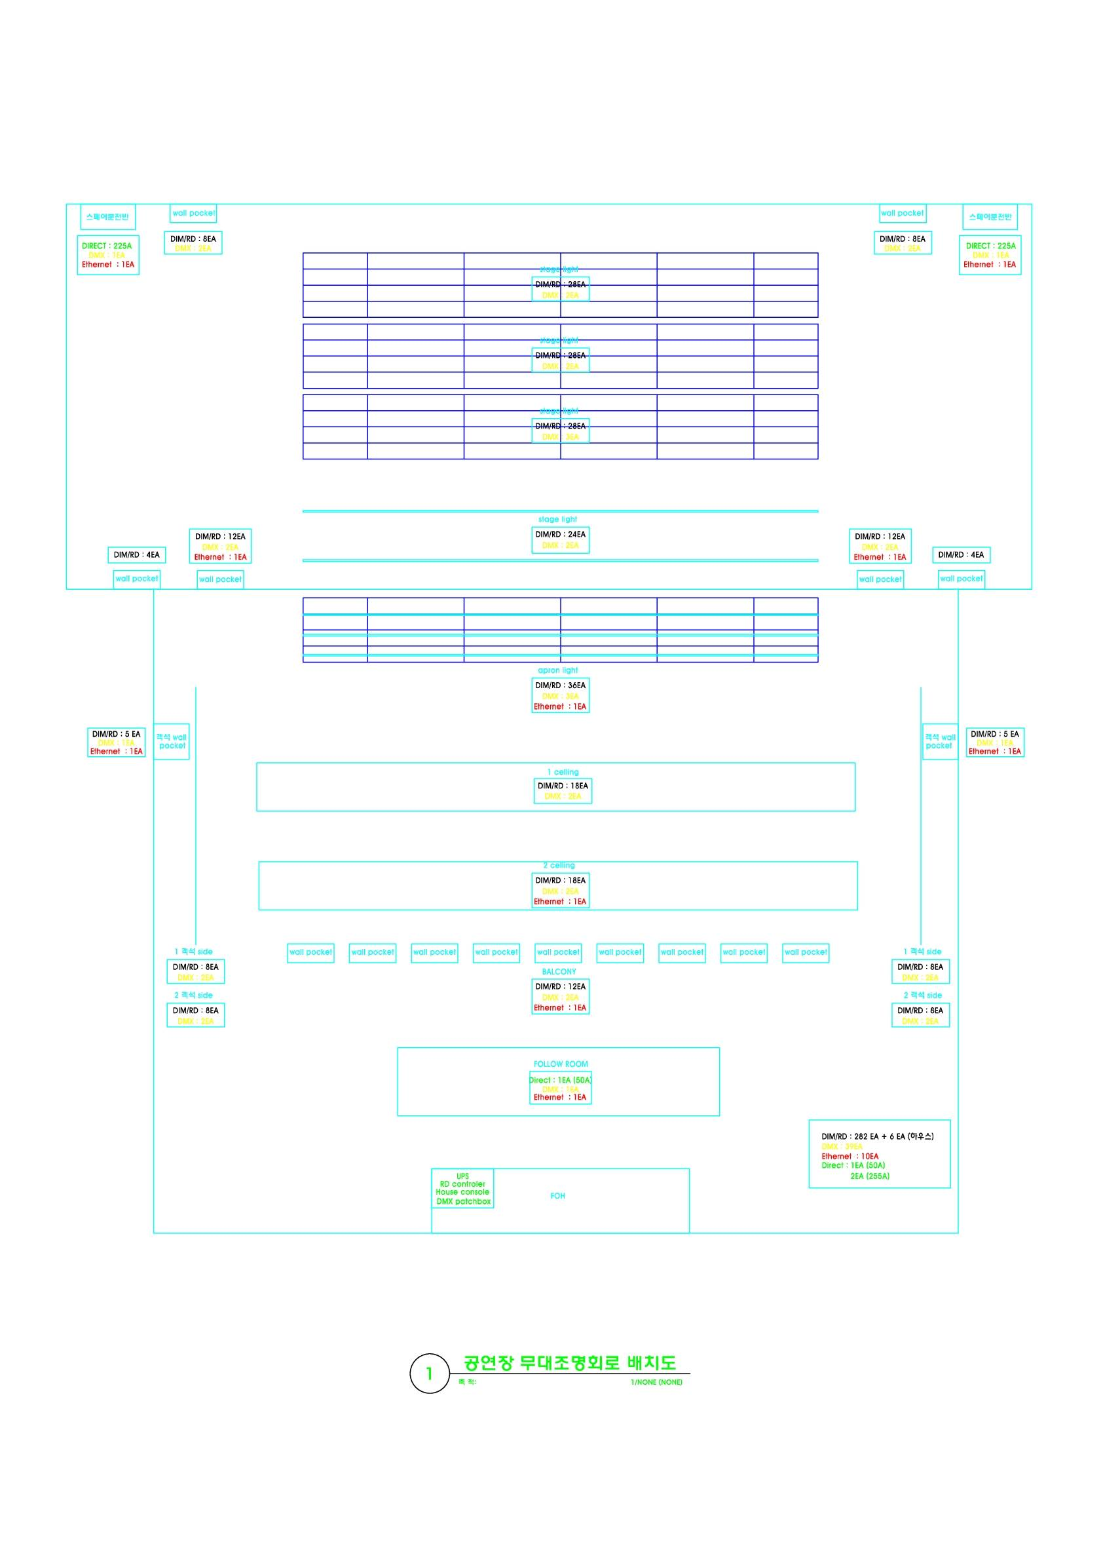

▷ 조명 회로 번호 배치도

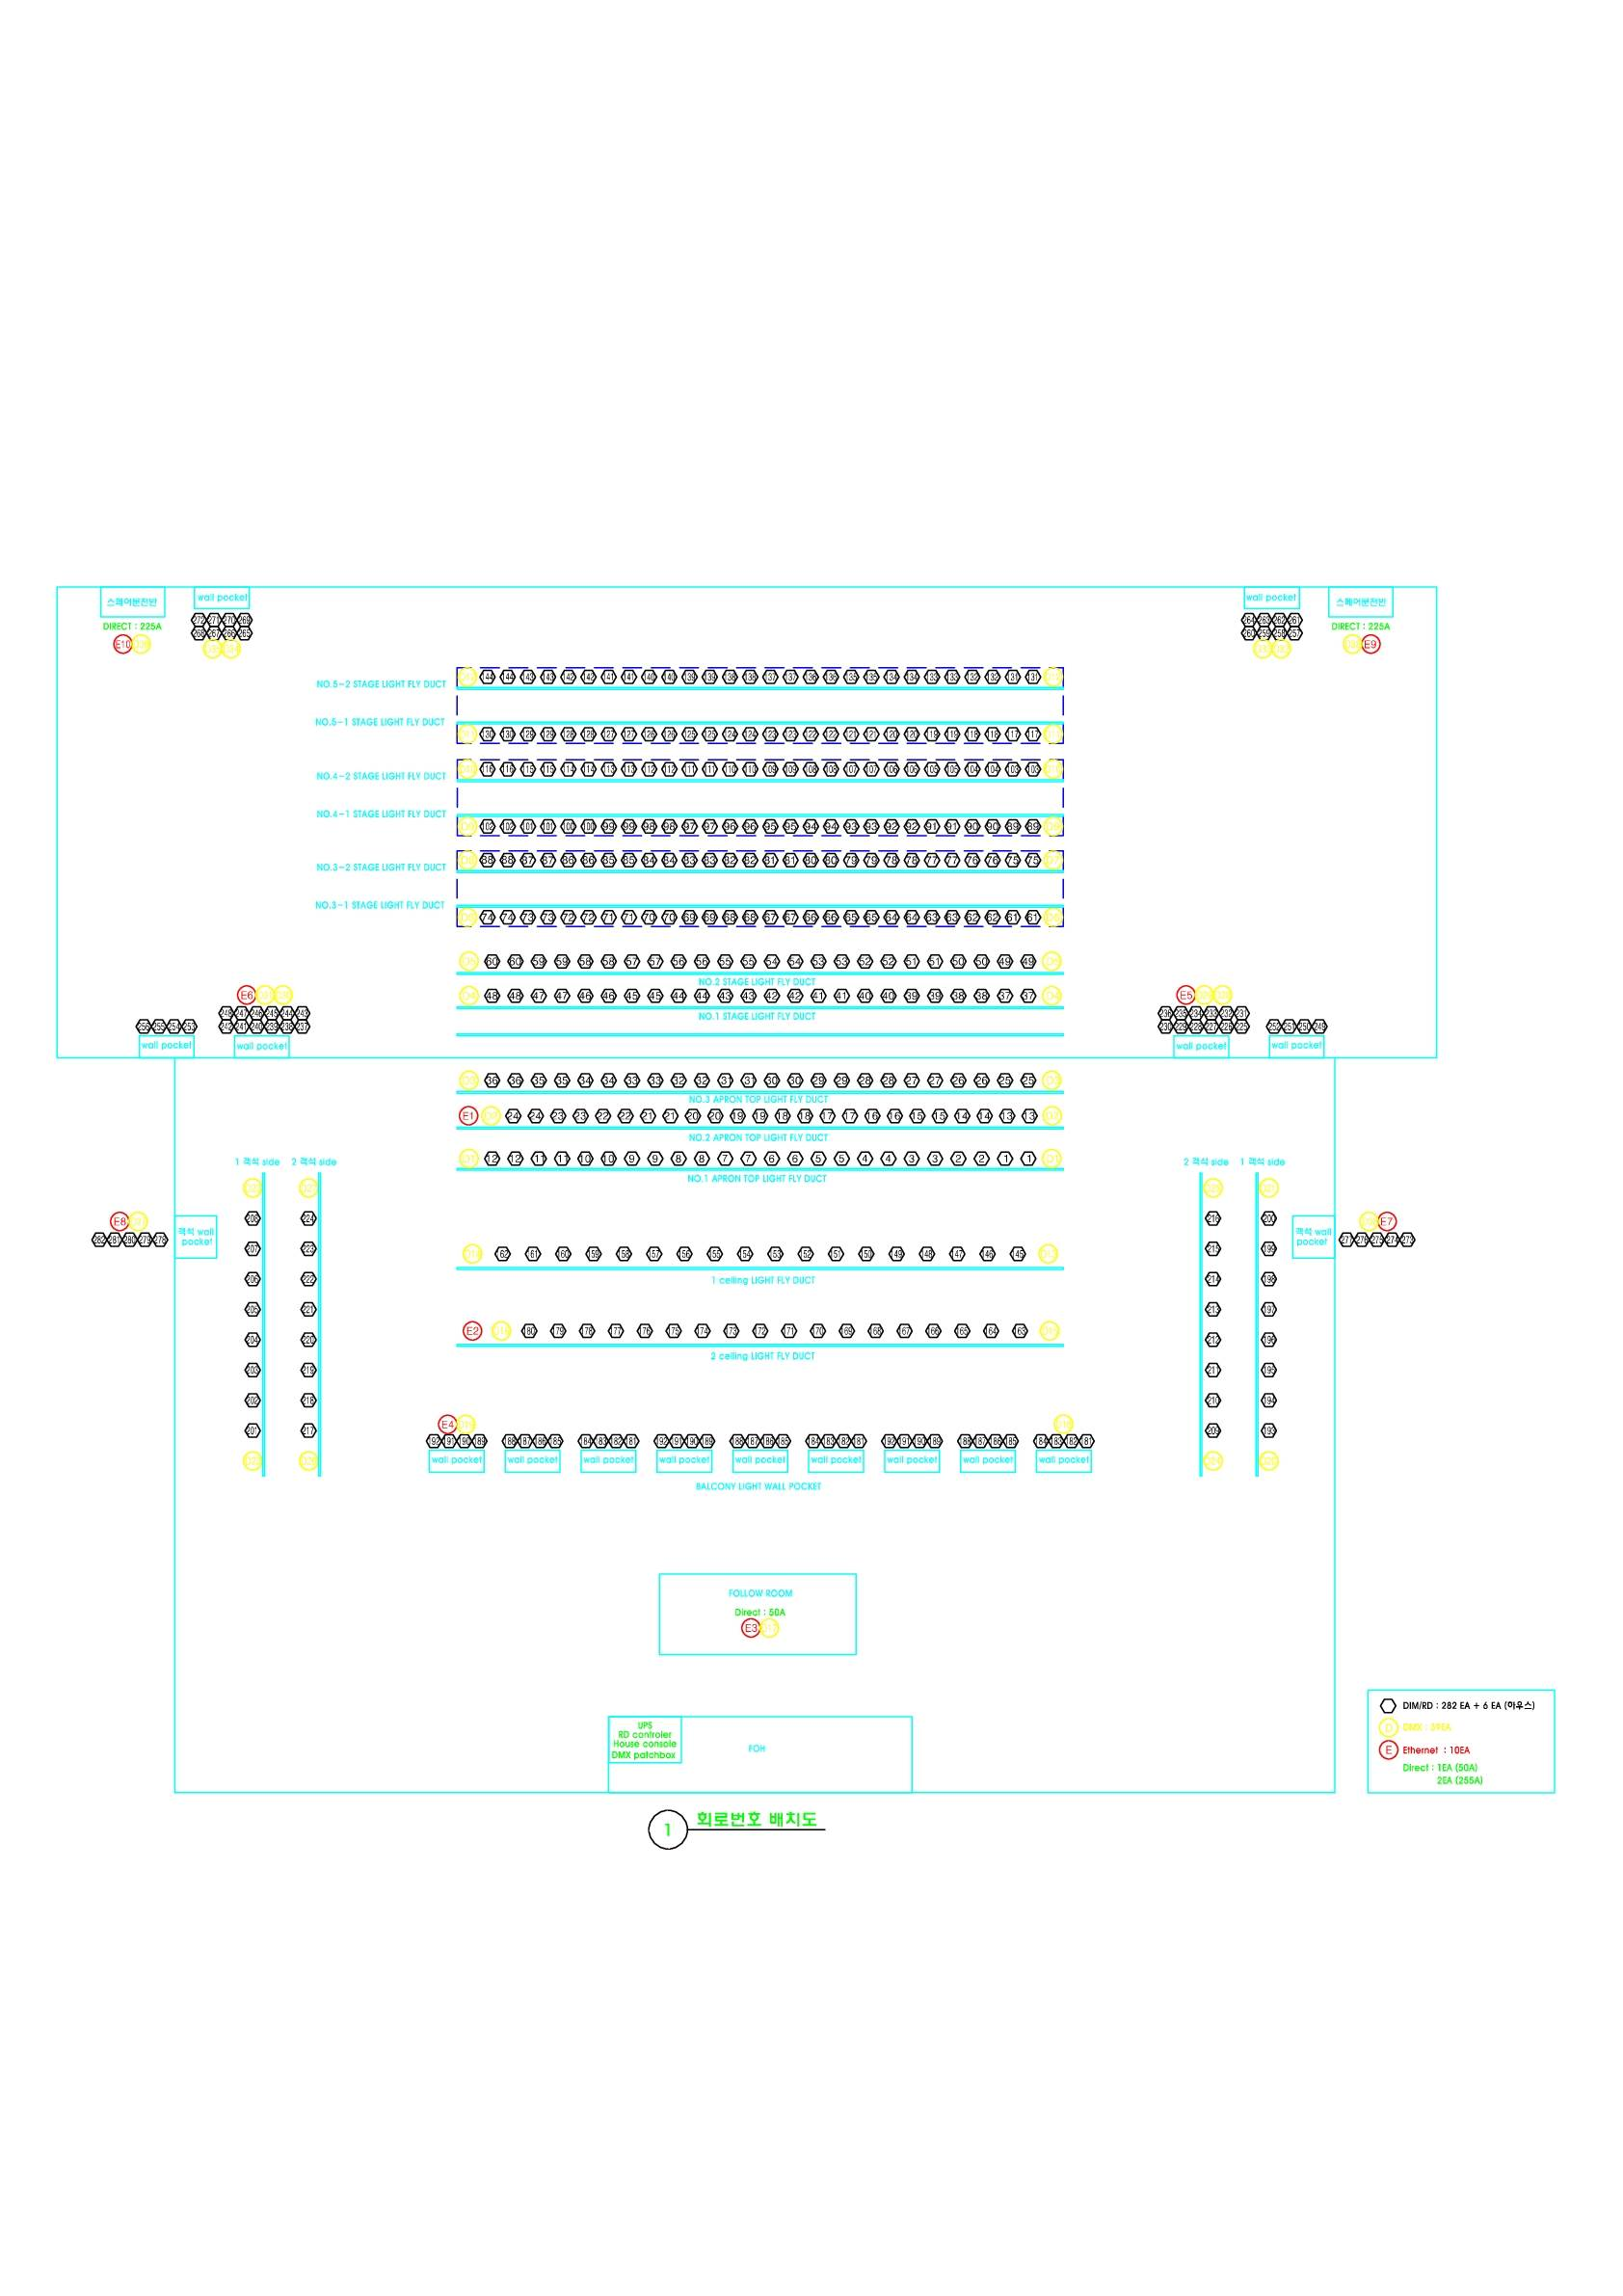

▷ 음향 배치도 1층

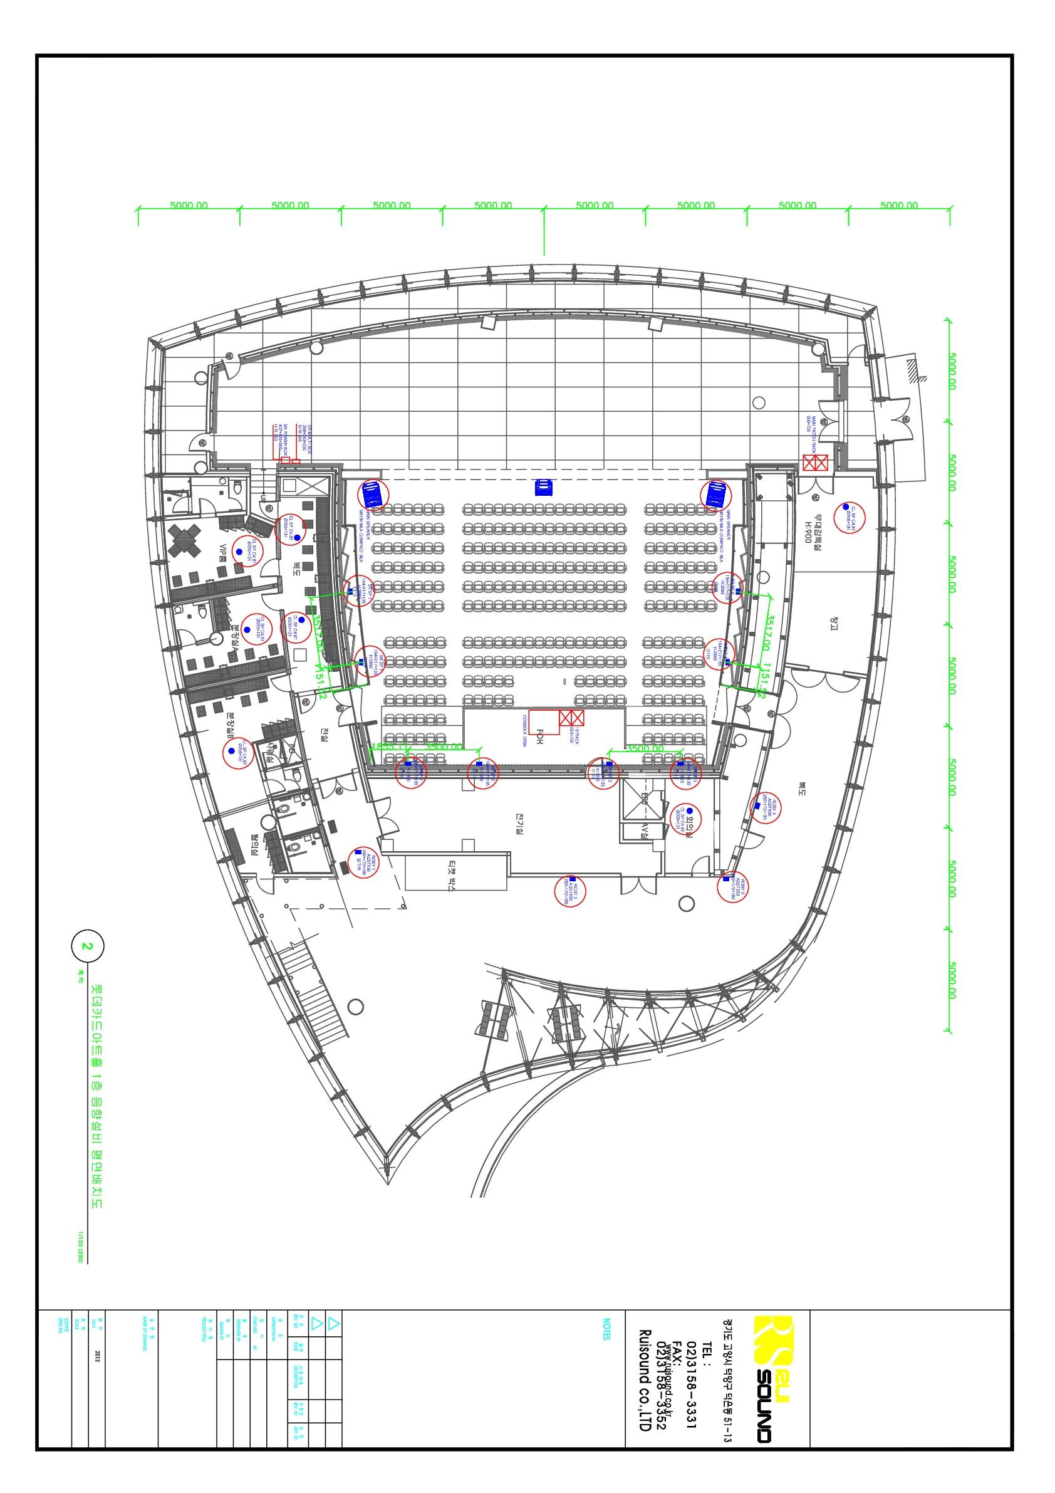

▷ 음향배치도2층

